WebHosting for your website

# Step 1 – Create an account on Github

Start by creating an account on github.com.

Write your owner/user name exactly as it shows up on Github here: ­­­­__________­­­­_____________

# Step 2 – Create a new repository

After adding your account to GitHub, create a new repository. Click on the “+” sign at the top right cornor of your account page.

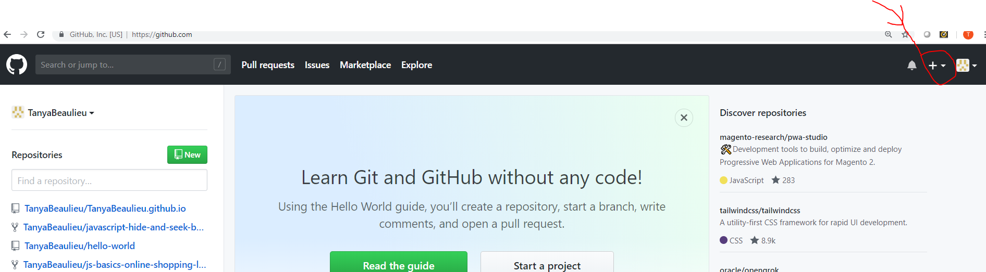

# Step 3 - Enter in your data to set up your repository:

Name the repository: *Owner*.github.io – where you use your specific owner (user) name.

Make the Repository Public

Click the “Initialize this repository with a README” file

Click the green button “Create repository”

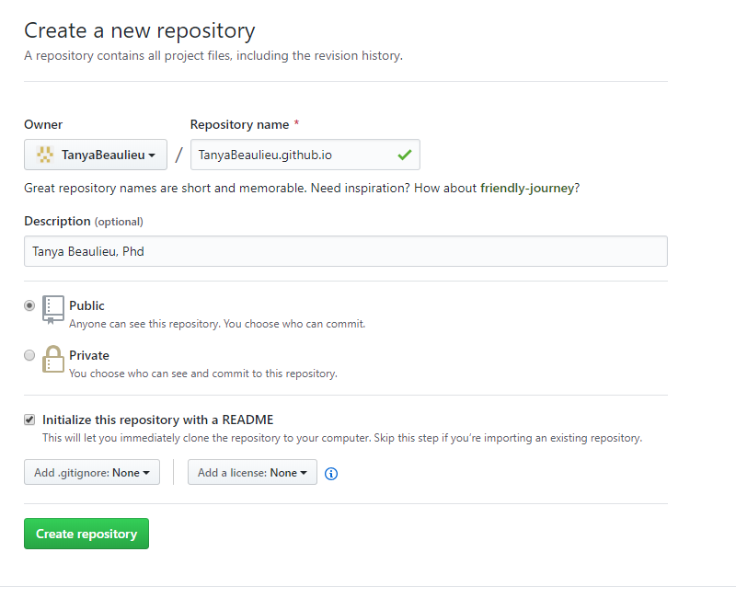

# Step 4 - Next, upload your files

After your repository is created, click “Upload Files”

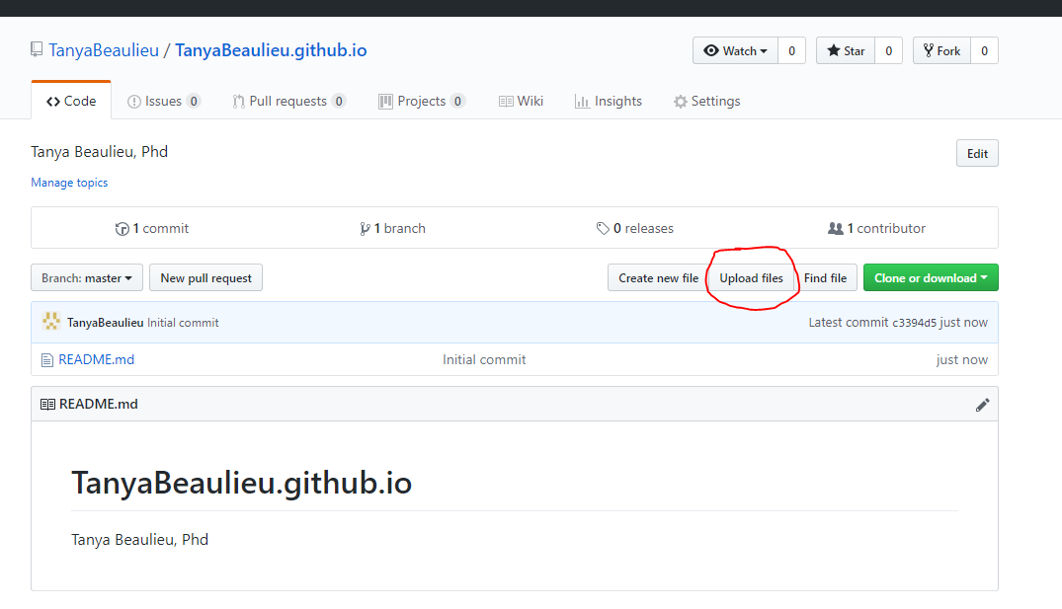

# Step 5 - Drag or browse for your files.

Once your files have been added to the repository, click ‘commit’ to save the changes

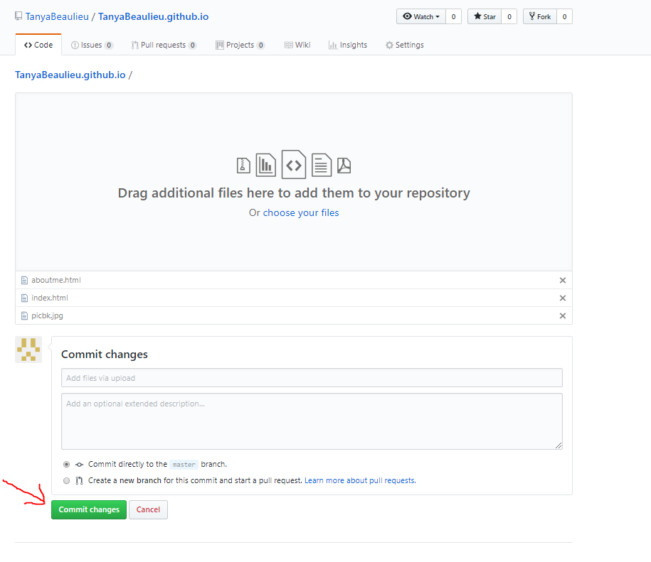

# Step 6 – Test it out

Go to a new window, and type in your url: *owner*.github.io (of course use your own owner name).

Did your page appear? Yay!!

Example: tanyabeaulieu.github.io